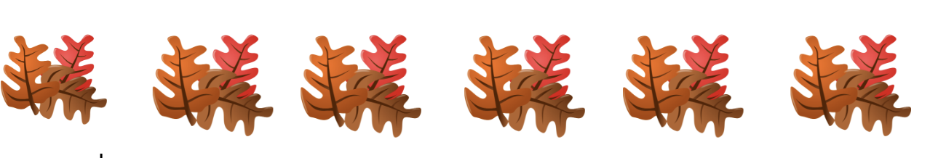
Topic; Introducing Chemistry Department Chair
Speaker: Hai tao lu
- Explanations of tracks you can take using your chemistry major.
- We have local non student chapters for ACS- anyone can join
  - A lot of outreach- working with Carnegie Science center, working with high schools… etc
  - Great way to stay within the ACS community after graduating.
- Career options
  - Teach
  - Research: writing proposals and papers etc.(PHD)
  - Need of polymech chemists and Analytical chemists in industry.
  - Can be a junior chemist - a lot of people choose to go back to graduate school in order to go into industry at a higher position.
- Advice
  - Almost always need to have a postdoc in order to get into research
  - It is important to be able to talk to people outside of your circle.
  - Connections are important
  - If you want to go to industry, try to get internships
  - Postdoc is not necessary for working in industry

Attendance:

9/22/2023 11:55:25 | Janice Park | Senior | Jap295@pitt.edu
9/22/2023 11:55:30 | Christina Raad | Junior | chr119@pitt.edu
9/22/2023 11:55:31 | Ahssan Sekandari | Senior | ahs52@pitt.edu
9/22/2023 11:55:38 | Holly Krug | Senior | hxk1@pitt.edu
9/22/2023 11:56:24 | Dhruthi | Senior | dhg15@pitt.edu
9/22/2023 12:00:48 | Corrinne Stahl | Senior | CES165@pitt.edu
9/22/2023 12:01:22 | McKenna gallagher | Junior | meg196@pitt.edu
9/22/2023 12:01:25 | Precious Nwankwo | Senior | prn26@pitt.edu
9/22/2023 12:01:29 | Abigail Stubenbort | Senior | Aes187@pitt.edu
9/22/2023 12:01:32 | Steve Duchi | Freshman | sad280@pitt.edu
9/22/2023 12:01:51 | Michaela Schiele | Junior | Mcs164@pitt.edu
9/22/2023 12:02:10 | Michael chipman | Freshman | MWC29@pitt.edu
9/22/2023 12:02:11 | Charlie Rudolph | Junior | CFR15@pitt.edu
9/22/2023 12:02:13 | kiu sui jerry cheung | Senior | kic29@pitt.edu
9/22/2023 12:02:17 | Olivia Wood | Sophomore | orw14@pitt.edu
9/22/2023 12:02:21 | Cailey Dolata | Sophomore | cad251@pitt.edu
9/22/2023 12:02:40 | Joy Prasch | Junior | Jcp102@pitt.edu
9/22/2023 12:03:01 | Sofia Wilson | Sophomore | sew142@pitt.edu
9/22/2023 12:03:04 | Kieran Dudek | Sophomore | kjd87@pitt.edu
9/22/2023 12:03:27 | Jack Cicero | Freshman | jfc70@pitt.edu
9/22/2023 12:03:48 | Alex mcquain | Senior | Adm169@pitt.edu
9/22/2023 12:03:55 | Madison Martin | Sophomore | mem507@pitt.edu
9/22/2023 12:03:55 | Herbert Edmonds | Junior | Hde2@pitt.edu
9/22/2023 12:04:07 | Marin George | Sophomore | mpg61@pitt.edu
9/22/2023 12:04:19 | Ryan Racioppo | Senior | rtr22@pitt.edu
9/22/2023 12:04:35 | Laurel Beckman | Sophomore | LEB191@pitt.edu
9/22/2023 12:04:39 | Dennis Skiba | Senior | dns42@pitt.edu
9/22/2023 12:04:56 | Piper Read | Senior | Per36@pitt.edu
9/22/2023 12:05:26 | Don Truong | Senior | dnt13@pitt.edu
9/22/2023 12:48:49 | George Fritze | Senior | gwf8@pitt.edu
9/22/2023 12:48:56 | Allie Redhair | Junior | amr296@pitt.edu
9/22/2023 12:49:00 | sophie bazydola | Junior | sob50@pitt.edu
9/22/2023 12:49:35 | Nina Bao | Sophomore | nib127@pitt.edu
9/22/2023 12:49:38 | Lauren McNutt | Junior | lmm261@pitt.edu
9/22/2023 12:49:56 | Anna Welser | Senior | alw243@pitt.edu
9/22/2023 12:50:00 | Shane Osborne | Senior | SHO29@pitt.edu
9/22/2023 12:51:05 | Isabella Mateo | Senior | ism29@pitt.edu
9/22/2023 13:51:08 | Gabriel Davis-Andres | Senior | gad52@pitt.edu

